FIREFOX (49.0.2) (WINDOWS 7):

Region Dropdown:

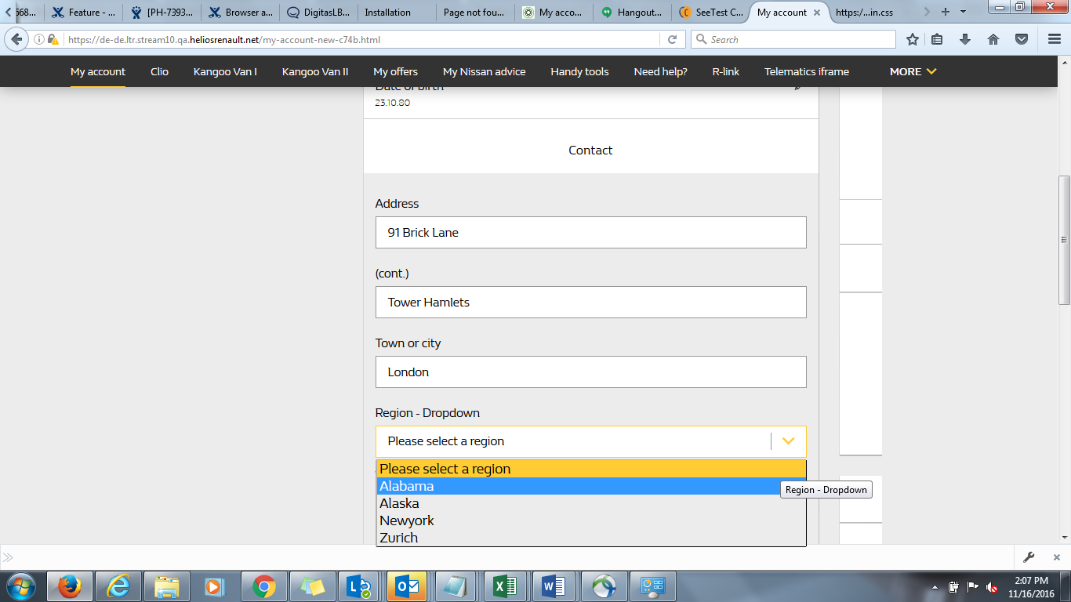

IE 11 (WINDOWS 7):

Region Dropdown:

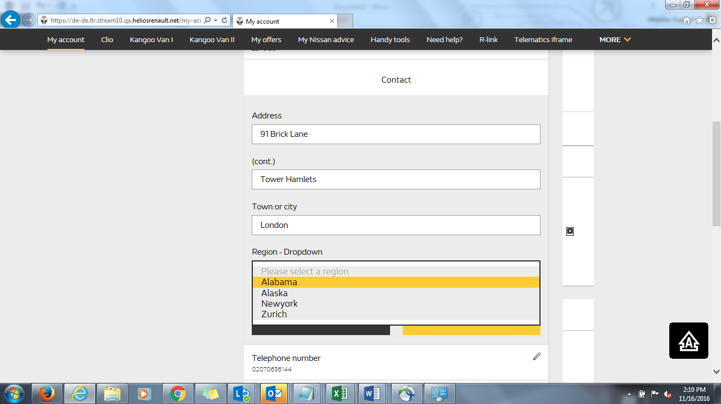

CHROME (54.0.2):

Region Dropdown:

